NAME: S. DHARANI
REG NO: 192472364
COURSE CODE: DSA0401
NUMPY / PANDAS ANALYSIS – QUESTIONS AND ANSWERS
QUESTION 4: QUARTERLY SALES ANALYSIS
AIM:
To calculate the total annual sales and percentage increase from the first quarter to the fourth quarter using NumPy.
ALGORITHM:
1. Import NumPy.
2. Create an array containing the sales for four quarters.
3. Calculate total sales using np.sum().
4. Calculate percentage increase using the first and fourth quarter values.
5. Display the results.
CODE:
import numpy as np
sales_data = np.array([1000, 1200, 1500, 2000])
total = np.sum(sales_data)
increase = (sales_data[3] - sales_data[0]) / sales_data[0] * 100
print("Total sales:", total)
print("Percentage increase:", increase, "%")
INPUT:
[1000, 1200, 1500, 2000]

OUTPUT:
Total sales: 57000
Percentage increase: 100.0 %
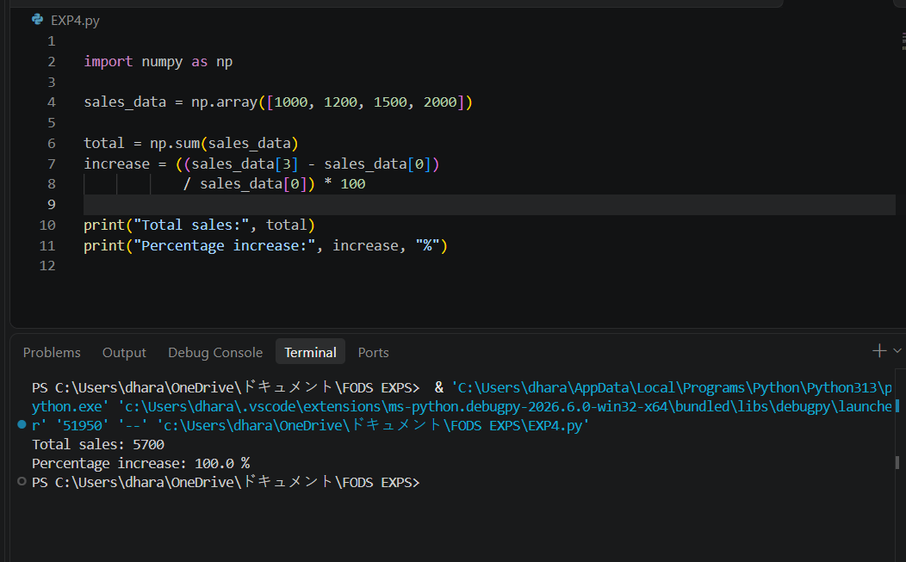
RESULT:
Total sales and the percentage increase were calculated successfully.

